Zonal Load Factor Analysis
Norbert Doerry
May 26, 2026
- Introduction
Zonal load factor analysis seeks to avoid inadvertently establishing too low of a power rating for power system equipment that may be possible with load factor analysis due to cycling and intermittent loads. Setting load factors for 24-hour calculations is straight forward for loads: divide the long-term average power in a given operational condition and ambient condition by the load’s connected load. If the load is a cycling load, the average power is likely considerably less than the peak power; yet the power system should be capable of powering this peak load when the load is “on.” If there are many cycling loads, then the probability that all the cycling loads are on at the same time is very low; the power system equipment usually does not need to have the capability to supply all of the cycling loads at the same time.
- Cycling loads
Figure 1 depicts a waveform of a cycling load along with nine constant power (10 kW) loads. Cycling loads are typically on for a period of time, then off for possibly a different period of time. The time that the load is off and the load is on can vary. In this case, the cycling load has a peak load of 50 kW; is on between 3 and 4 time units, and is off between 27 and 36 time units. The on and off times are randomly selected within their limits.
Assuming the peak value of the cycling load is the connected load, the appropriate load factor for its 24-hour average computations would be calculated by dividing the waveforms average value by its connected load. In Figure 1, the average value of the total combined waveform is 95 kW with the cycling load contributing 5 kW. Since the cycling load has a connected load of 50 kW, the load factor for 24-hour average computations is therefore 0.10.
The peak value of the combined load is 140 kW; if the average value of 95 kW is used to determine the required rating of the power system equipment, the power system equipment may be overloaded and not operate as expected in service.
Figure 2 depicts the combined power waveform of 8 constant power loads (10 kW each) and two cycling loads as in Figure 1. The average load is 90 kW with each of the cycling loads contributing 5 kw. The cycling loads each have a load factor for 24-hour average computations of 0.10. The peak value of the combined load is 180 kW; the duration of this peak value is likely to be less than the average on time of each of the cycling loads.
Figure 3 depicts the combined power waveform of 7 constant power loads (10 kW each) and three cycling loads as in Figure 1. The average load is 85 kW with each of the cycling loads contributing 5 kW. The cycling loads each have a load factor for 24-hour average computations of 0.10. For this waveform the peak value of the combined load is 170 kW. While it is possible to have a peak value of 220 kW, this will seldom occur; if does occur, it will likely have a short duration.
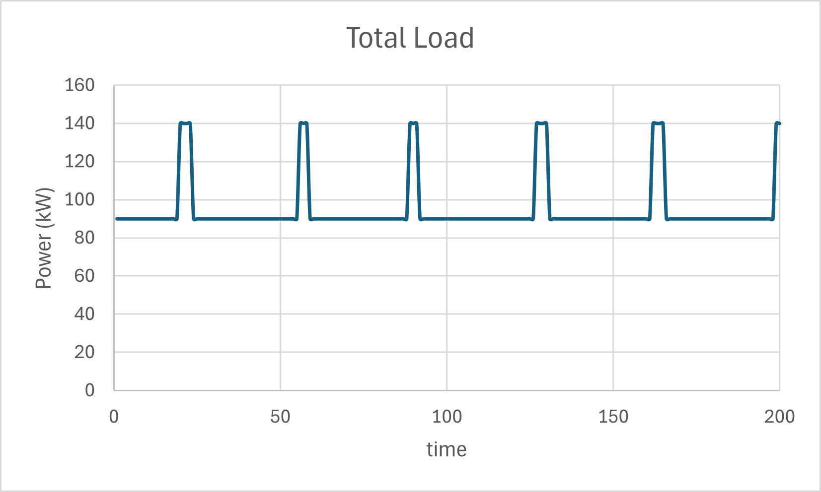
Figure 1: Cycling load with nine constant power loads
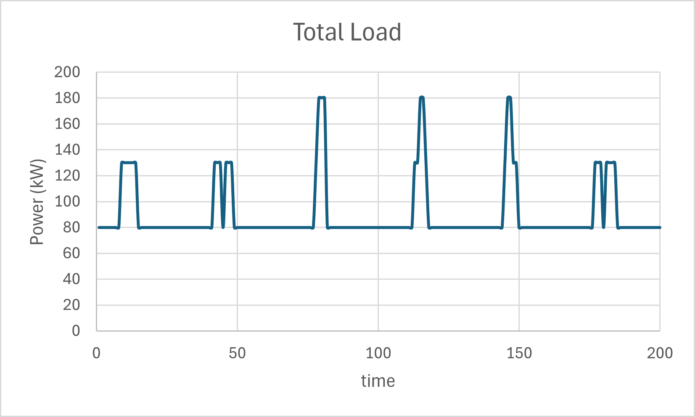
Figure 2: Two cycling loads with eight constant power loads
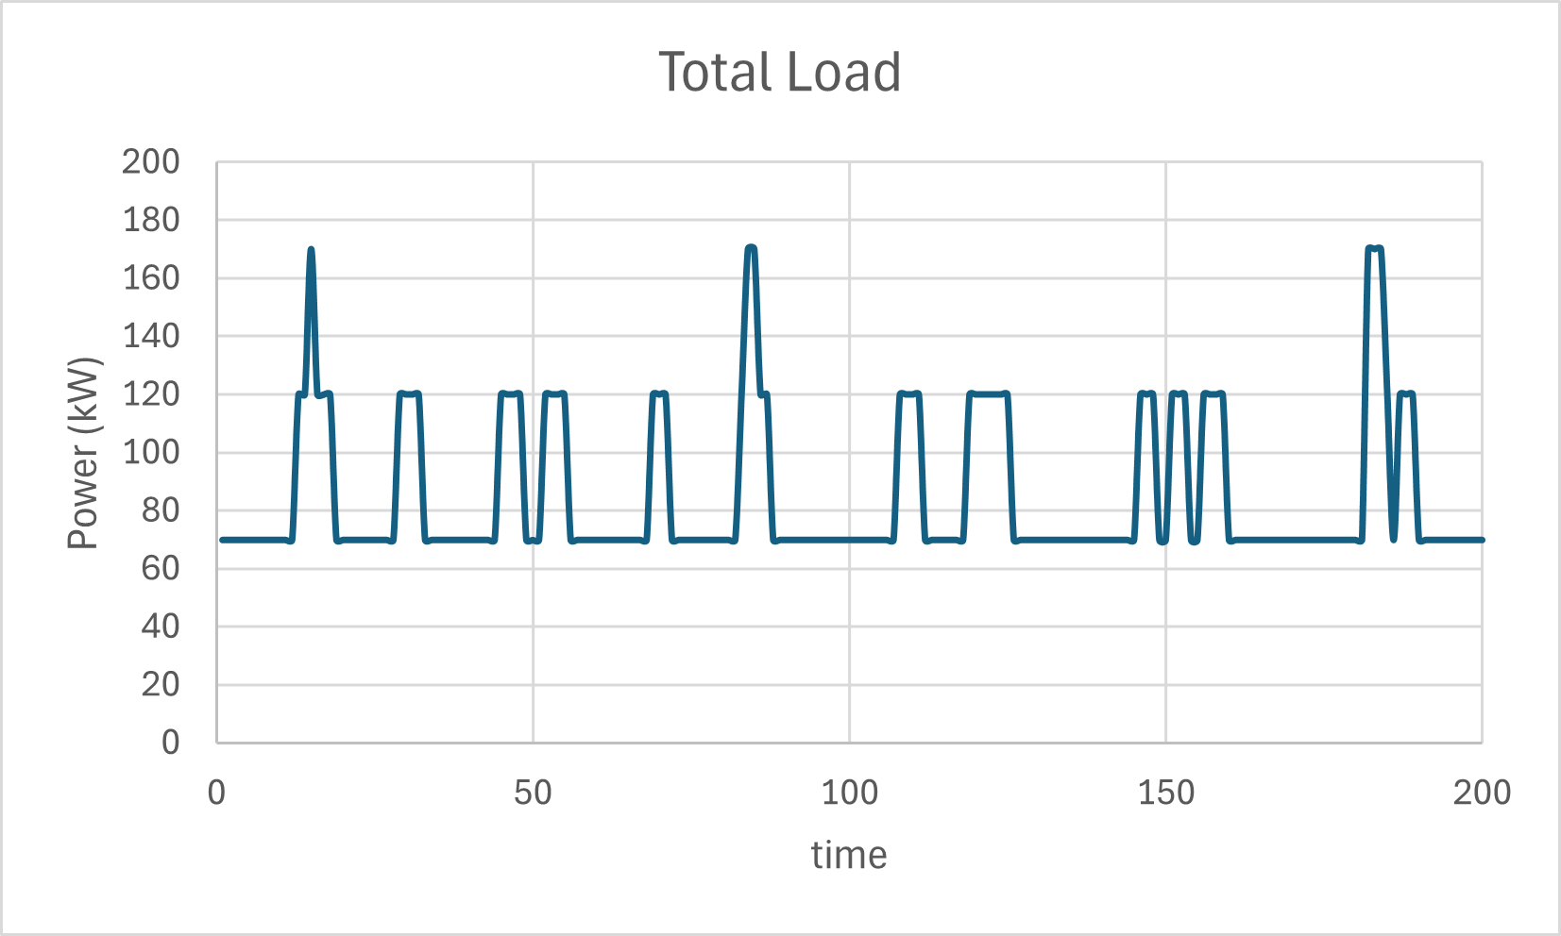
Figure 3: Three cycling loads with seven constant power loads
It should be clear that when the total load has a significant contribution from cycling loads, the average value is likely too small to be used to determine the rating of power system equipment.
- Calculating Zonal Load Factors
The zonal load factor method’s goal is to determine a reasonable value to use for sizing power system equipment. When cycling loads are present, it produces a higher load than when using the 24-hour average-based load factors. The zonal load factor is calculated using the following equation from DPC 310-1 which is depicted graphically in Figure 4:
$$L_{fz_{j}}=L_{f_{j}}+\left(\frac{P_{P_{j}}}{P_{L_{j}}}-L_{f_{j}}\right)\left(\frac{P_{P_{j}}}{\sum_{i=1}^{n}{L_{f_{i}}P_{L_{i}}}}\right) \text{for} \frac{P_{P_{j}}}{\sum_{i=1}^{n}{L_{f_{i}}P_{L_{i}}}}<1.0$$
$$L_{fz_{j}}=\frac{P_{P_{j}}}{P_{L_{j}}} \text{for} \frac{P_{P_{j}}}{\sum_{i=1}^{n}{L_{f_{i}}P_{L_{i}}}}≥1.0$$
Where
$L_{fz_{j}}$ = Zonal load factor for load j
$L_{f_{j}}$ = Load factor for load j for 24-hour average calculations
$P_{L_{j}}$ = Connected Load (kW) for load j
$P_{P_{j}}$ = Peak Load (kW) for load j
$n$ = Number of loads
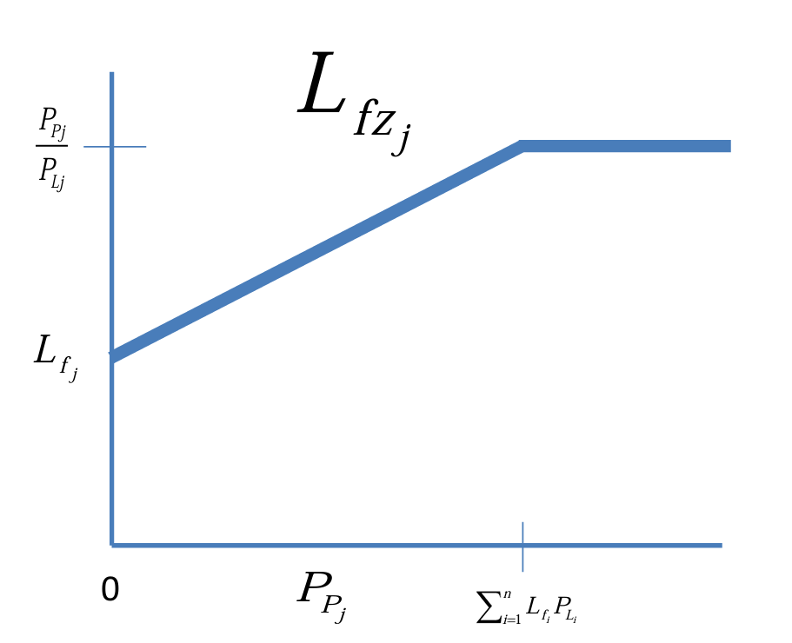
Figure 4: Zonal load factor
For the example depicted in Figure 1, the zonal load factor for the cycling load is:
$$L_{fz_{j}}=0.10+\left(1-0.10\right)\left(\frac{50}{95}\right)=0.574$$
The zonal load factor for each of the constant power loads is the same as the 24-hour average load factor:
$$L_{fz_{j}}=1+\left(1-1\right)\left(\frac{10}{95}\right)=1$$
For the example depicted in Figure 2, the zonal load factor for the cycling load is:
$$L_{fz_{j}}=0.10+\left(1-0.10\right)\left(\frac{50}{90}\right)=0.60$$
Note that the zonal load factor is influenced by the other loads.
For the example depicted in Figure 3, the zonal load factor for the cycling load is:
$$L_{fz_{j}}=0.10+\left(1-0.10\right)\left(\frac{50}{85}\right)=0.629$$
- Calculating Zonal Total Operating Load
The zonal total operating load is equal to the sum of the zonal operating loads plus the maximum residual zonal power demand. The zonal operating load for each load is obtained by multiplying the zonal load factor by the load’s connected load. For each load, the residual zonal power demand is the difference between the peak load and the zonal operating load. For constant power loads, the residual zonal power demand is zero.
For the example in Figure 1, the zonal operating load for the cycling load is 0.574 × 50 = 28.7 kW. The residual power demand for the cycling load is 50 – 28.7 = 21.3 kW. The zonal total operating load is therefore 9 × 10 + 28.7 + 21.3 = 140 kW. In the case of a single cycling load, the zonal total operating load is the same as the peak value of the total load.
For the example in Figure 2, the zonal operating load for the cycling loads is 0.60 × 50 = 30 kW. The residual power demand for each of the cycling loads is 50 – 30 = 20 kW. The zonal total operating load is therefore 8 × 10 + 30 × 2 + 20 = 160 kW. Compare this with the peak value of the combined load of 180 kW. The peak load, which does not occur as frequently as the cycling load, is 12.5% greater than the zonal total operating load. Under normal operation, sources are typically not loaded beyond 95% of their rated output. Furthermore, most sources are capable of short-term overloads of at least 10% of their rated output. Between these two factors, the source is likely not to be overloaded when both cycling loads are online. Closer examination is warranted if the source is a power electronic converter with minimal overload capability.
For the example in Figure 3, the zonal operating load for the cycling loads is 0.629 × 50 = 31.47 kW. The residual power demand for each of the cycling loads is 50 – 31.47 = 18.53 kW. The zonal total operating load is therefore 7 × 10 + 31.47 × 3 + 18.53 = 182.9 kW. Compare this with the observed peak value of 170 kW and the possible peak value of 220 kW. The zonal total operating load is greater than the observed peak value and the possible peak value is about 20% greater than the zonal total operating load. The overload capability of the sources should be examined to determine if the short-duration overloads of magnitude 15% can be tolerated (assuming maximum 95% loading of sources).
- Calculating Zonal Demand Power
The zonal demand power is calculated by applying margin and service life allowance to the zonal total operating load. The zonal demand power should be used to determine the minimum rating of the associated power system equipment.
- References
DPC 310-1 Electric Power Load Analysis (EPLA) for Surface Ships

